**Environment Monitoring System Documentation**

|  |
| --- |
| **Table of Contents**  1. Introduction  2. Hardware Components  3. Software Components  4. Hardware Setup  5. Software Setup  6. Coding the ESP32  7. Server-Side Setup  8. Data Display |

**1. Introduction**

The Environment Monitoring System is designed to monitor and collect data on environmental parameters such as temperature, humidity, and air quality. The system is built around an ESP32 microcontroller, MQ gas sensor, DHT sensor, and a server for data visualization. This documentation provides a detailed guide for setting up the system.

**2. Hardware Components**

Required Hardware:

- ESP32 Development Board

- MQ Gas Sensor (e.g., MQ-7 for CO or MQ-135 for various gases)

- DHT Sensor (e.g., DHT11 or DHT22)

- Power supply for ESP32 (USB cable or battery)

- Internet connection (Wi-Fi)

- Server (you can use a cloud server, Raspberry Pi, or any web server)

**3. Software Components**

Required Software:

- Micropython

-Thonny

- Libraries for DHT and ESP32

**4. Hardware Setup**

Connect the MQ Gas Sensor and DHT Sensor to the ESP32 following their respective datasheets for pin assignments and power requirements. Power the sensors correctly and provide power to the ESP32 via a USB cable or an external source. This ensures accurate sensor readings and proper operation of the microcontroller.

**5. Software Setup**

Install MicroPython and Thonny . Once installed, open Thonny, and configure it for ESP32 development, setting up the appropriate COM port and device settings. Next, install the necessary libraries for the project, such as libraries for DHT and ESP32 by navigating to "Sketch," then selecting "Include Library," and finally, clicking on "Manage Libraries."

**6. Coding the ESP32**

To create a Thonny sketch for reading sensor data and sending it to a server, import the necessary libraries for the sensors, ESP32, and network communication , configure the sensor connections and initialize the network connection which is Wi-fi and read data from the sensors and process it , and finally, adapt the code to send the data to the server using the HTTP protocol .

**7. Server-Side Setup**

Set up a server to receive and store the data. Here local server is used.

**8. Data Display**

Once data is received by the server, it is displayed on the webpage

This documentation provides an overview of the Environment Monitoring System, providing an insight to hardware and software setup, coding, server configuration, and data display.

**DESIGN:**

**TOP VIEW:**

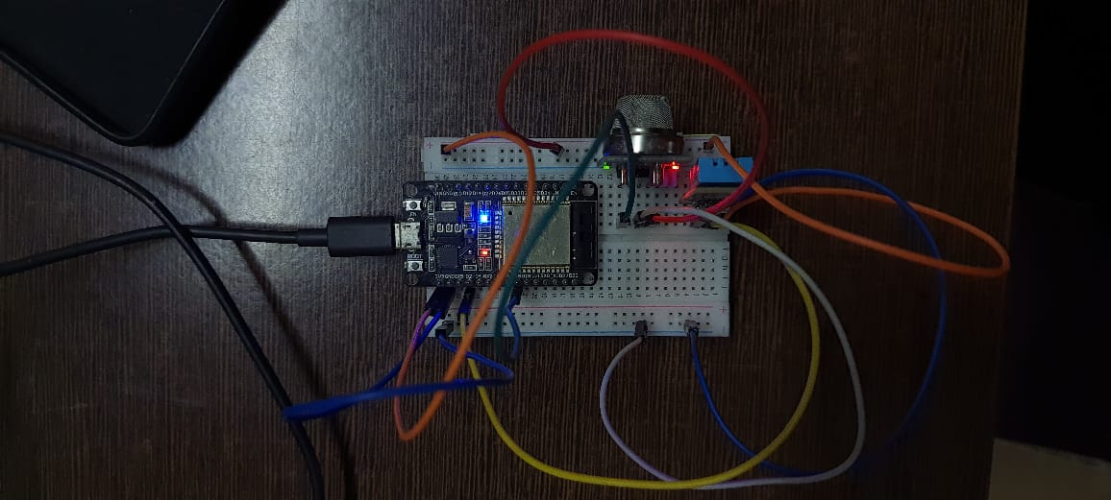

**SIDE VIEW:**

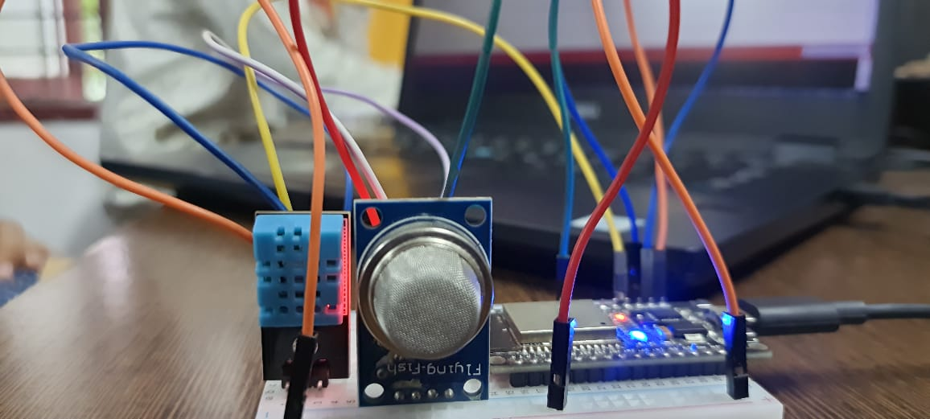

**SERVER:**

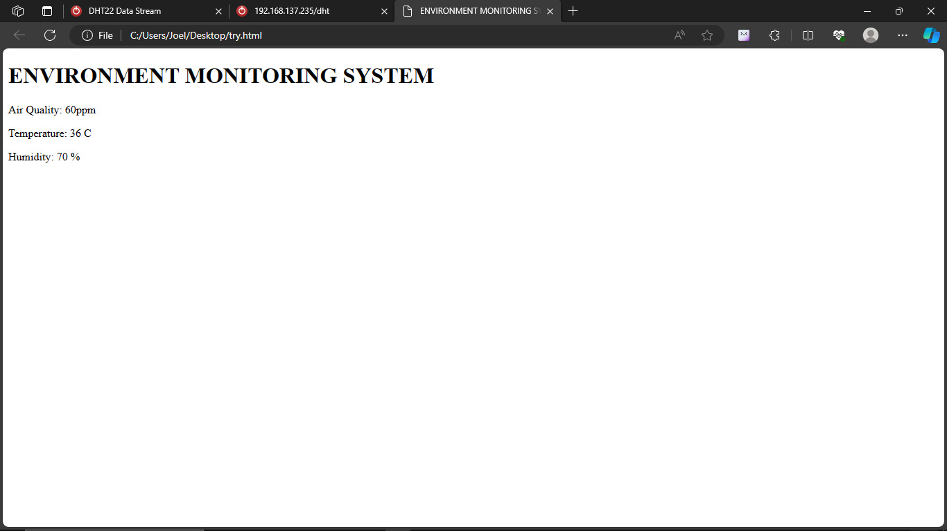

**CODE:**

